 | DigiLearn-Training Management  System  Technical Design Document  1.0
 | Prepared By / Last Updated By | Reviewed By | Approved By
Name | Aditi Narang | Subham kumar | Ms. Vasundhara Bagde
Role | Team Member | Team Member | Scrum Master
Signature
Date | 04/16/2019 | 04/16/2019 | 04/16/2019

Table of Contents

1.0 Introduction 4
1.1 Purpose of this document 4
1.2 Scope 4
1.3 Intended Audience 4
1.4 Definition & Acronyms 4
2.0 Assumptions, Dependencies and Risks 5
2.1 Assumptions: 5
2.2 Dependencies: 5
3.0 Schematic Diagram 6
4.0 Use Case Realization 7
4.1.1 User/Admin Registration 7
a. Functional Requirement 7
b. UI Validations 7
c. UI Controls 7
d. UI Methods Definition 8
e. UI Design 8
4.1.2 User Credential Authentication 8
a. Functional Requirement 8
b. UI Validations 8
c. UI Controls 9
d. UI Methods Definition 9
e. UI Design 9
4.1.3 Admin Page 10
a. Functional Requirement 10
b. UI Validations 10
c. UI Controls 10
d. UI Methods Definition 10
e. UI Design 11
4.1.4 User Page 11
a. Functional Requirement 11
b. UI Validations 11
c. UI Controls 11
d. UI Methods Definition 12
e. UI Design 12
4.1.5 Tests 12
a. Functional Requirement 12
b. UI Validations 13
c. UI Controls 13
d. UI Methods Definition 13
e. UI Design 13
5.0 Database Design 14
5.1 Data Model 14
The following is a schematic view of the database design 14
5.2 Tables Structure 15
6.0 Change Log 17

Introduction

Purpose of this document
The purpose of the detail design document is to define the detailed design for all the components of Training Management System that are specified in the Business Requirement/Use case document. All the low level components, interfaces and integrations are detailed out in this document.

Scope
This sub-section shall state the scope of this detailed design document
• Create and maintain user information.
• Create and maintain admin information.
• Create and maintain course information.
• Create and maintain test information.

Intended Audience
The intended audience for this document are
- Developers, testers, other associates in the project
- Technical lead, Scrum Master
- Product Owner

Definition & Acronyms

Assumptions, Dependencies and Risks
Acronyms | Definitions
TMS | Training Management System

Assumptions:
- Once the application is built the Training Management System will manually load the user list into the system.
- There will be no concurrent users for the application. The User profile will be maintained by the User.
- Any changes to the design mentioned in the BRD would be taken as a Change Request

Dependencies:
- Availability of database design characteristics & access shall be defined by the
- Resource availability throughout each of the sprint

Schematic Diagram
A schematic, or schematic diagram, is a representation of the elements of a system using abstract, graphic symbols rather than realistic pictures. It gives an overview of overall system

DFD for Training Management System

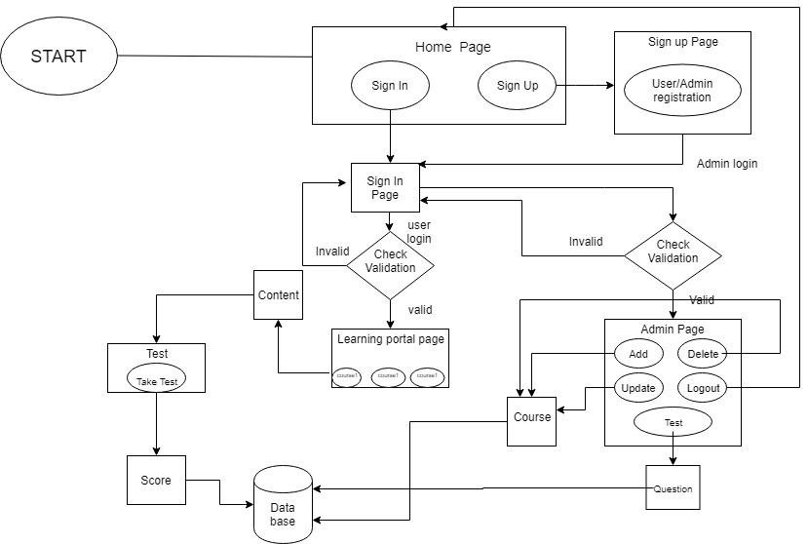

Use Case Realization

User/Admin Registration

Functional Requirement
This use case deals with the capture of user details. The ‘user’ here shall be the operator of the system and will be keying in the user details.

UI Validations
- All fields are mandatory.
- Password should have maximum 15 alphanumeric, space & can contain special characters (ex.!,@,#,%,*,& etc.)
- The Email ID format must be checked.
- Phone Number must be of 10 digits’ length.
- First Name, Last Name should contain only alphabets.
- Gender should be chosen from the dropdown options.

UI Controls
# | UI Component | Type | Name | Details
1 | First Name | Text Field | firstName | To enter first name
2 | Last Name | Text Field | lastName | To enter last name
4 | Age | Text Field | Pan | To enter age
5 | Gender | Text Field | age | To enter gender
6 | Contact Number | Text Field | gender | To enter contact no
7 | UserId | Text Field | contactNo | To enter user id
8 | Email Id | Text Field | username | To enter email id
9 | Password | Text Field | emailId | To enter password
10 | User Type | Text Field | User type | To enter user type

UI Methods Definition
Method Name | Parameter | Details
Registor_button | Object User | Allows the user to register his details

UI Design

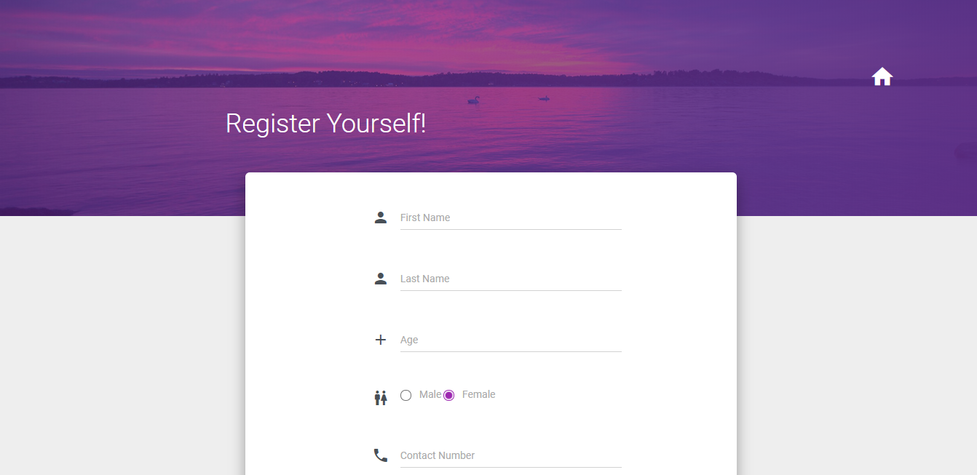

User Credential Authentication

Functional Requirement
. Login Page checks the authentication of the user and based on his role, directs the user to the respective page.

UI Validations
- User Id and Password fields are mandatory.
- Invalid User Id and / or password should not allow the user to get into the system

UI Controls
# | UI Component | Type | Name | Details
1 | Username | Text Field | username | To enter username
2 | Password | password | password | To enter password

UI Methods Definition
Method Name | Parameter | Details
Login_Button | Object User | Allows the user to login into the portal
Register_Button | None | Allows the user to register his details
Admin/User | None | Allows the user to select admin/user

UI Design
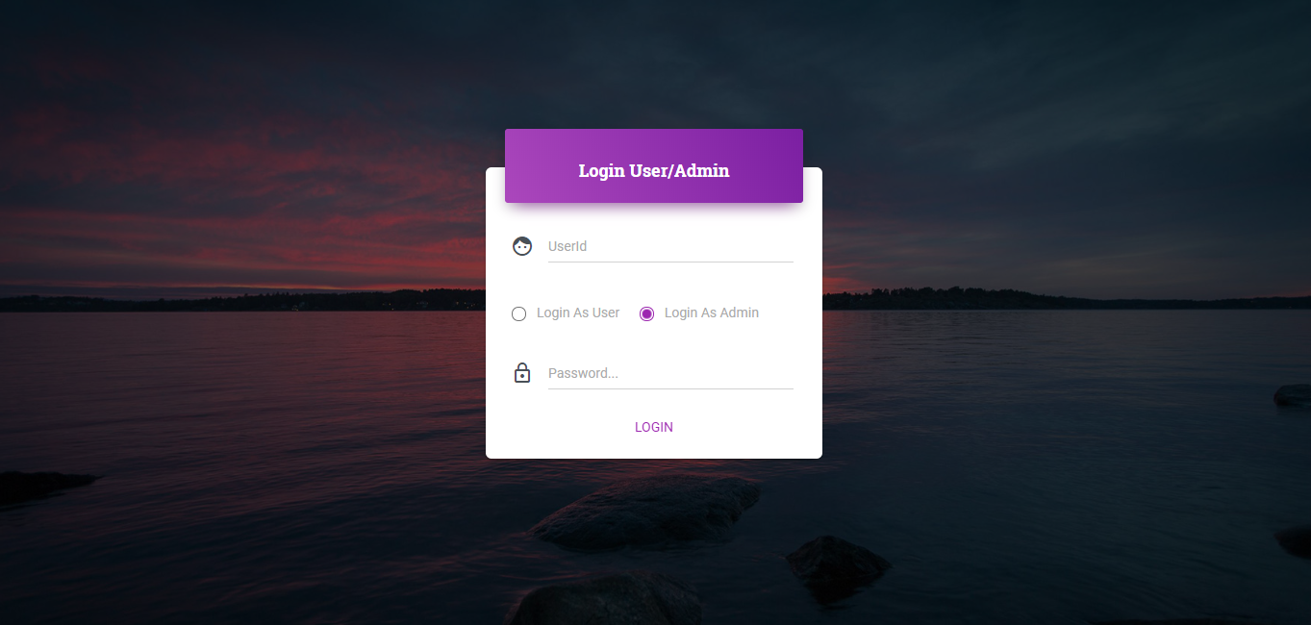

Admin Page

Functional Requirement
This use case deal with the display of Admin view page after successful login.

UI Validations
- Successful validation at login page.

UI Controls
# | UI Component | Type | Name | Details
1 | Add Course | button | addcourse | To add new course
2 | View Course | button | viewcourse | View the list of existing course
3 | Delete Course | button | deletecourse | Delete course
4 | Update Course | button | address | Update an existing course

UI Methods Definition
Method Name | Parameter | Details
Add Course | Course details
View Course | none
Delete Course | Course id
Update Course | Course id, new details

UI Design


User Page

Functional Requirement
This use case deal with the display of User view page after successful login.

UI Validations
- Successful validation at login page.

UI Controls

# | UI Component | Type | Name | Details
1 | View Courses Details | view | addcourse | To add new course
2 | Search Course | text | viewcourse | View the list of existing course

UI Methods Definition

UI Methods Definition

Method Name | Parameter | Details
Viewcourses | none
Searchcourse | Course name

e. UI Design

Tests

Functional Requirement
This use case deals with the ability of the user to give the tests if he or she completed the course. Each course have their own test, which was uploaded by the admin, and user can see their score and their performance.

UI Validations
- Successful completion of course taken

UI Controls
# | UI Component | Type | Name | Details
1 | View Courses Details | view | addcourse | To add new course
2 | Search Course | text | viewcourse | View the list of existing course

UI Methods Definition

Method Name | Parameter | Details
Logout | None | Allows the user to logout
test | Object User | Allows user to give the tests
Back | Object User | Allows user to redirect to course

UI Design
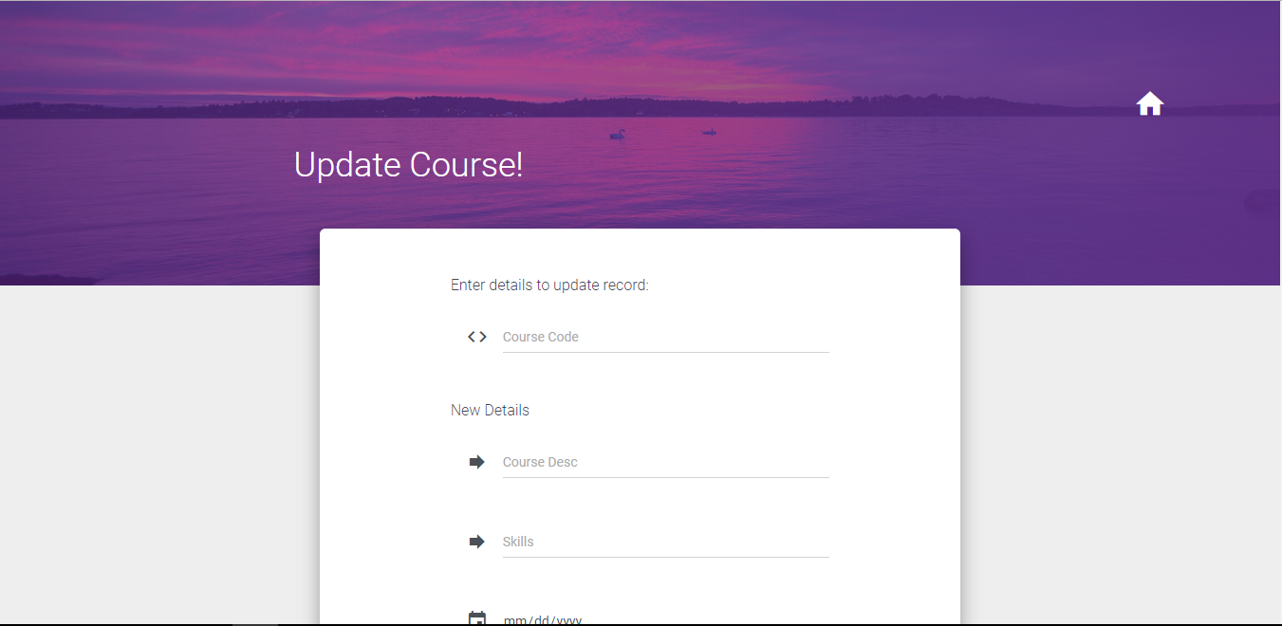

Database Design

Data Model

The following is a schematic view of the database design
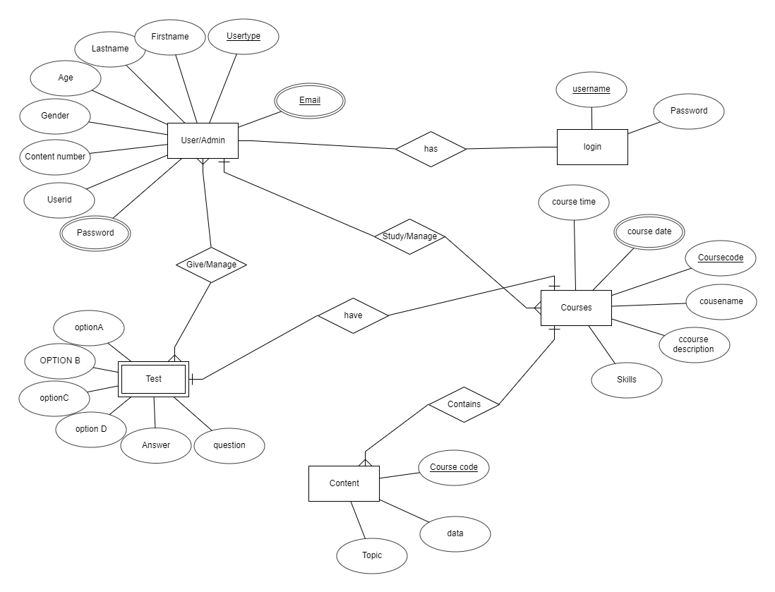

Tables Structure
User Details:
Column Name | Data Type | Length | Nulls
first Name | varchar | 50 | N
last Name | varchar | 50 | N
age | number | 2 | N
gender | varchar2 | 10 | N
Contact number | number | 10 | N
User id | varchar2 | 15 | N
password | varchar2 | 15 | N
email | varchar2 | 50 | N
usertype | varchar2 | 1 | N

Course:
Column Name | Data Type | Length | Nulls
Course code | varchar2 | 10 | N
Course name | varchar2 | 20 | N
Course_desc | varchar2 | 100 | N
skills | varchar2 | 10 | N
Course_date | varchar2 | 10 | N
Course_time | varchar2 | 10 | N
Course_date | varchar2 | 10 | N

Content Details:
Column Name | Data Type | Length | Nulls
Course_code | varchar2 | 10 | N
topic | varchar2 | 30 | N
data | Varchar2 | 100 | N

Question Details:
Column Name | Data Type | Length | Nulls
Course_code | varchar2 | 10 | N
Question number | varchar2 | 30 | N
question | Varchar2 | 100 | N
Option1 | Varchar2 | 10 | N
Option2 | Varchar2 | 10 | N
Option3 | Varchar2 | 10 | N
Option4 | Varchar2 | 10 | N

Score Details:
Column Name | Data Type | Length | Nulls
Course_code | varchar2 | 10 | N
Username | varchar2 | 30 | N
Score | Varchar2 | 100 | N

Change Log
Please note that this table needs to be maintained even if a Configuration Management tool is used.
Version Number | Changes made
V1.0 | <First version>
V1.1 | <If the change details are not explicitly documented in the table below, reference should be provided here>
V1.1 | Page no | Changed by | Effective date | Changes effected
V1.2 | <If the change details are not explicitly documented in the table below, reference should be provided here>
V1.2 | Page no | Changed by | Effective date | Changes effected

